**Curriculum Vitae**

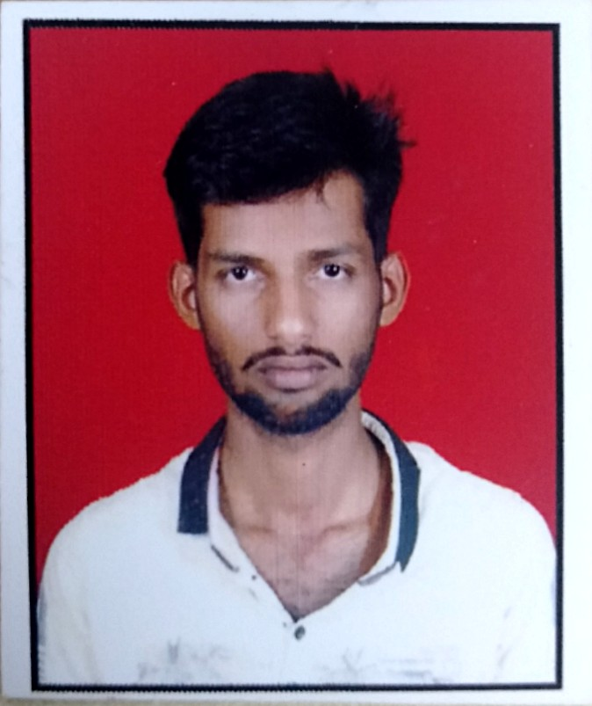

Please affix a

Passport size

photo here

# Name : Mr. Nihal Mulla

**Address : Danoli Road, Malbhag, Kumbhoj.**

**Tal:- Hatkanangle, Dist:- Kolhapur.**

**Mobile No : 9834028983**

# E-mail : nihalmulla9784@gmail.com

**Academic Qualifications:**

|  |  |  |  |  |  |
| --- | --- | --- | --- | --- | --- |
| **Degree / Certificate** | Qualification | Institute | Board /University | **Year** | **Aggregate % / CGPA** |
| Graduation | B.C.A | DKASC  College | Shivaji Uni. Kolhapur | 2019 | **66.39** |
| 12th | Commerce | Junior College,  Kumbhoj | State Board | 2016 | **64.74** |
| 10th | Marathi | New English  School, Kumbhoj | State Board | 2014 | **60.20** |

|  |  |
| --- | --- |
| **Please mention any pending Backlogs in your Academic Career** | **NO** |

**Trainings / Projects Undertaken:**

|  |  |  |
| --- | --- | --- |
| **Name of Institute / Organization** | **Project Title** | **Duration** |
| **-** | Bank Management System (C#.NET) | 30 Days |
| **-** | Inventory Management System (Python, Django Framework) | 1 Week |
| **_** | Result Finder (PHP, MySql) | 30 Days |

**Additional Qualification / Achievements / Certifications:**

* Introduction to Cyber Security – CISCO Certification
* Certified Ethical Hacker – Udemy Certification
* MSCIT (Global Tech MSCIT)

**Subjects of Interest:**

* Operating System
* Software Engineering
* Research – This is not a subject but I includes this because I like to research in technologies, And I’m publish total 2 research papers.
* Ethical Hacking.
* CyberSecurity.

**Computer Proficiency:**

* Programming Languages - C , C++, C#.NET, Python, Python-Django, HTML5, CSS3.
* HTML, CSS
* Operating System-Windows

**Hobbies:**

* Research In new things and write paper on that, And I’m publish two research papers.
* Programming, Designing Databases, Frameworks,etc .